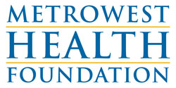
MetroWest Health Internship Fund Application

Please fill out a separate application for each intern for whom you are seeking funding. Email your completed application to Rebecca Donham at rdonham@mwhealth.org.

Organization Information

- Organization Name:

- Organization Address:

- Organization Contact Name and Title:

- Contact phone and email:

Internship Details

- Name of intern (if known):

- Are you seeking an intern for direct clinical care or community health improvement?
Direct Clinical Care ____ Public Health ____

- From which school and program will you recruit the intern?

- Start and end dates of the internship:

- How many weeks do you plan to engage the intern?

- How many hours each week?

- What amount are you requesting for the stipend?

- Who will supervise the intern (name and title)?

Project Details

- Briefly describe the work to be done by the intern.

- Briefly describe the population with whom the intern will be working.

- What skill or competencies will the intern learn from this work?

