CONFERENCE FACILITIES
The MetroWest Health Foundation supports community building by making its meeting space available to area nonprofits and community groups at no cost.

The space consists of a large conference room (maximum 40) and a small conference room (maximum
6). Space is available during regular business hours only and must be booked in advanced. Due to security issues the building is not accessible at night.

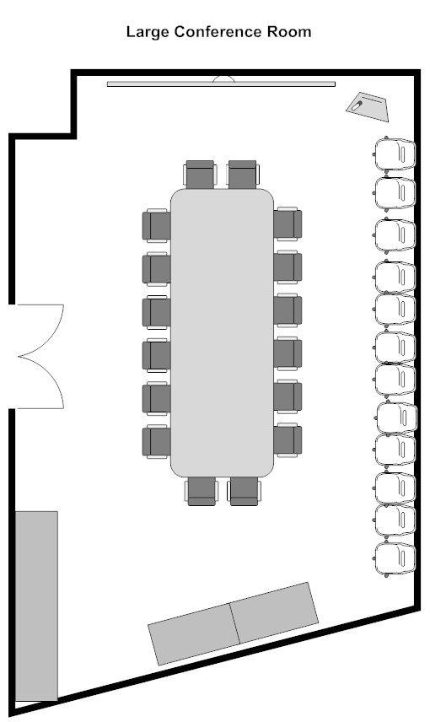

The building, meeting rooms and restrooms are handicapped accessible.

Organizations are welcome to bring in food or catering. We can assist in identifying area restaurants and caterers.

To reserve space, contact us at:
info@mwhealth.org

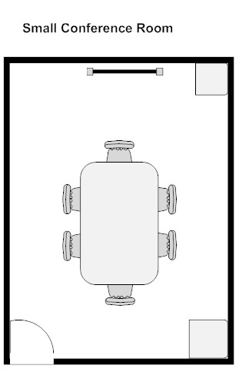

Audio-visual Equipment:

The large conference room is equipped with the following:
- Computer w/ 80” LCD screen & connections for laptops or tablets
- Blu-ray player
- Webcam conferencing
- Conference speakerphone
- Easel & pad

The small conference room is equipped with the following:
- Desktop LCD projector
- Whiteboard
- Easel pad
- Speakerphone

