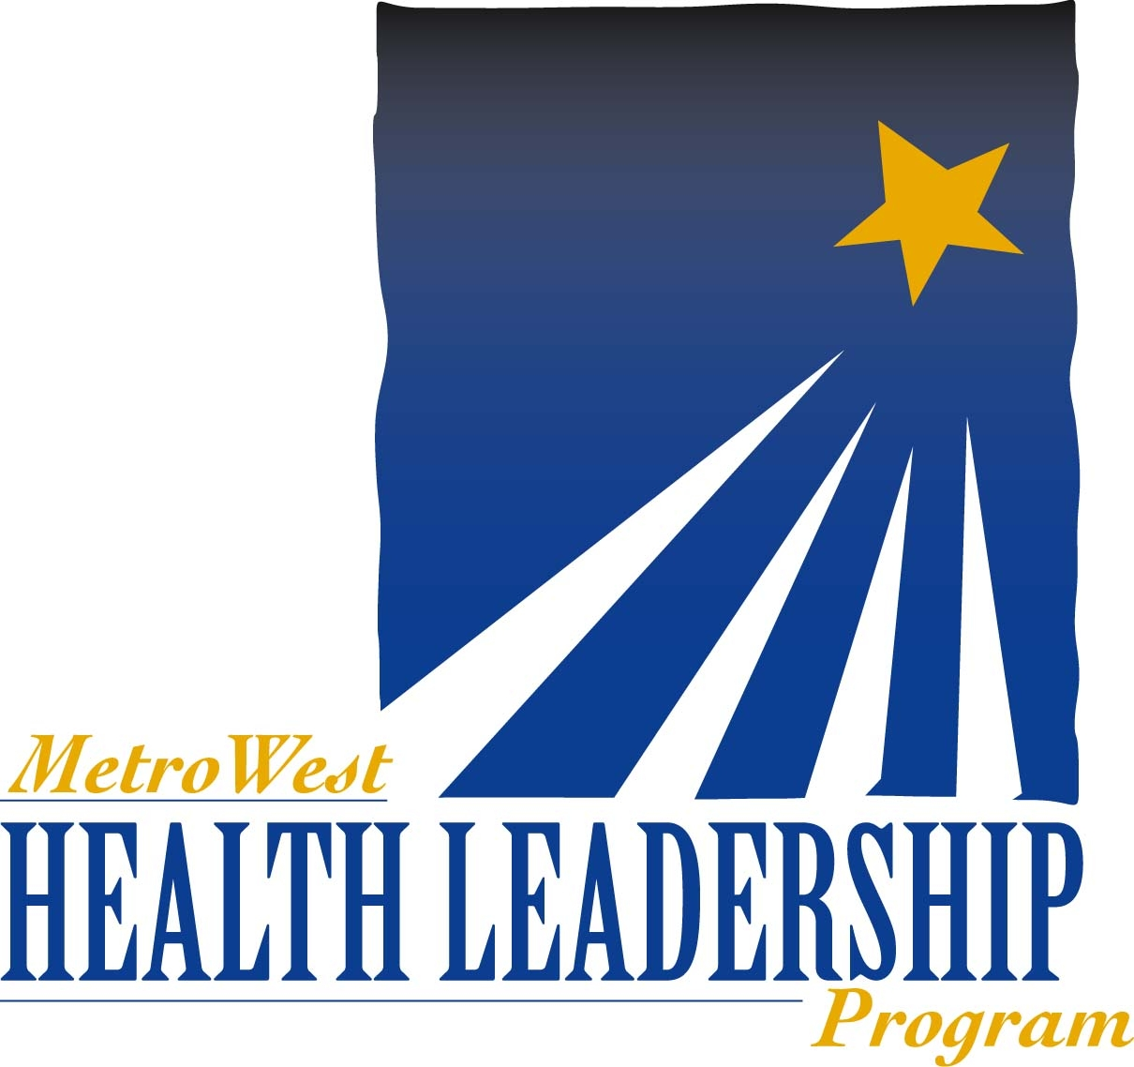

Application Due Date is Friday, November 9, 2025

Cover Sheet

Applicant Information

Name:

Home Address:

Preferred Email Address:

Employer Information

Employer:

Title:

Address:

Phone Number:

Years in the Position:

Years with the Organization:

Number of Direct Reports:

Name and Title of Supervisor:

Essay Questions

Applicant’s Name:

Please respond to the following essay questions in three pages or less. Please also attach a copy of an up-to-date resume.

Applications should be emailed to Rebecca Donham at rdonham@mwhealth.org.

- Describe your current position and responsibilities. Describe the management structure and your role within it as well as your managerial and supervisory experience.

- What specific leadership competencies do you want to develop or improve?

- Provide examples that demonstrate significant leadership accomplishments in your professional life.

- Describe a difficult or challenging situation you have experienced, what the result was and what you learned from it.

Supervisor Letter of Support

Applicant’s Name:

1. Please provide a brief letter of support attesting to the applicant’s leadership capabilities and potential, and their likelihood of improving the health and healthcare of the MetroWest region. In your recommendation, include the following:

- How long and in what capacity have you known the applicant.
- Why you believe the applicant is well suited to become a participant in the Health Leadership Program.
- The applicant’s potential for greater leadership roles in the delivery of health and health care services.

2. By signing the bottom of this form, you are certifying you understand that participants are required to attend all meetings, including a two-day retreat and six day-long sessions.

Signature: Date:

Name: Phone:

Organization: Email:

